LAB 4

Measurements with the oscilloscope

The aim of this LAB session is to familiarize the student with the main characteristics of the oscilloscope and measurement specifications. You will analyze the effect of the finite bandwidth of the oscilloscope on the signal parameters and the loading effect of the input impedance with and without an attenuating probe. You will check the effect of the noise and systematic errors of the oscilloscope in the measurement of the signal parameters (voltage and time)
The PreLab section is devoted to the analysis of the different effects on the measurements
PRE-LAB Exercises.
PRELAB4-1.- Estimate the theoretical rise time (between 10% and 90%) of the oscilloscope in the lab (BW=60MHz).
The theoretical rise time is considered in the industry to be:
$$t_{r}=\frac{0.35}{BW}=\frac{0.35}{60×{10}^{6}}=5.83×{10}^{-9}s=5.83 ns$$
$$t_{2,total}=\sqrt{t_{2}^{2}+t_{2 cable}^{2}}=\sqrt{{(5.83 ns)}^{2}+{(12.6 ns)}^{2}}=13.883 ns$$
PRELAB4-2.- Estimate the input impedance of the oscilloscope with a coaxial cable of 1 m at 10 kHz and 10 MHz (Rin=1 MΩ, Cin=15 pF, Ccoax(l)=100 pF/m).
$$C_{t}=C_{c}//C_{in}=C_{c}+C_{in}=15pF+100pF =115 pF$$
$$Z_{in}=Z_{1}+Z_{2}$$
$$Z_{1}=impedance relative to the oscilloscope probe=R_{p} // \frac{1}{sC_{p}}$$
$$Z_{2}=\frac{1}{sC_{t}}//R_{in}$$
If there is no probe: $Z_{in}=Z_{2}=\frac{1}{sC_{t}} // R_{in}=\frac{R_{in}}{1+R_{in}sC_{t}}$
$$s=jω=j×62.8×{10}^{3}$$
For 10 kHz:
$$w=2πf=2×π×10×{10}^{3}=62.8×{10}^{3} rad/s$$
$$Z_{in}=\frac{{10}^{6}}{1+\left({10}^{6}×115×{10}^{-12}×62.8×{10}^{3}j\right)}=\frac{{10}^{6}}{1+7.222j}=\frac{{10}^{6}×(1-7.222j)}{1+52.157}=\left(18812.097-135860.967j\right)Ω$$
$$\left|Z_{in}\right|=137157.2 Ω=137.157kΩ$$
For 10 MHz:
$$w=2πf=2×π×10×{10}^{6}=62.8×{10}^{6} rad/s$$
$$Z_{in}=\frac{{10}^{6}}{1+\left({10}^{6}×115×{10}^{-12}×62.8×{10}^{6}j\right)}=\frac{{10}^{6}}{1+7.222×{10}^{3}j}=\frac{{10}^{6}×(1-7.222×{10}^{3}j)}{1+52.157×{10}^{6}}=\left(0.0192-138.466j\right)Ω$$
$$\left|Z_{in}\right|=138.47 Ω$$
PRELAB4-3.-If we use an attenuating probe x10, what is the input impedance at the tip of the probe? (Suppose a coaxial cable for the probe with similar characteristics)

$$C_{t}=C_{in}+C_{c}$$
For low frequencies:
$$V_{o}=V_{g}×\frac{R_{in}}{R_{in}+R_{p}+R_{out}}=\frac{1}{10}→ R_{p}=9R_{in}$$
$$Z_{in}≅10MΩ$$
For high frequencies:
$$V_{o}=V_{g}×\frac{c_{p}}{C_{p}+\left(C_{in}+C_{c}\right)}$$
$$C_{p}≅\frac{C_{c}+C_{in}}{10} C_{c}+C_{in}=10C_{p}$$
$$Z_{in}=\frac{1}{j×2×π×f×\left(\frac{C_{c}+C_{in}}{10}\right)}$$
For the case of the probe:
$$Z_{in, probe}=10 MΩ //\frac{1}{j×ω×2×f×\left(\frac{C_{in}+C_{p}}{10}\right)}≈10Z_{in}$$
If the coax cable of the probe has the same characteristics of the coax cable, then:
$$R_{p}×C_{p}=C_{t}×R_{s}→\frac{V_{s}}{V_{in}}=\frac{R_{s}}{R_{s}+R_{p}}=\frac{1}{10} that is the probe atenuation x10$$
$$R_{s}+R_{p}=Z_{in}=R_{s}×10=1MΩ×10=10 MΩ$$
PRELAB4-4.- Estimate the measured rise time when connecting a 10 kHz square signal, with an output impedance of 1 kΩ, to the oscilloscope using a coaxial cable similar to PRELAB4-2.
From the information in Atenea:
$$t_{r}=\ln\left(9\right)×R_{out}×\left(C_{in}+C_{coax}\right)=\ln\left(9\right)×{10}^{6}×\left({15×10}^{-12}+{100×10}^{-12}\right)=252.68 us$$
PRELAB4-5. What will be the result for PRELAB4-4 if we use an attenuating probe x10?
$$t_{r}=\ln\left(9\right)×Z_{in probe}×\left(C_{in}+C_{coax}\right)=\ln\left(9\right)×10×{10}^{6}×\left({15×10}^{-12}+{100×10}^{-12}\right)=2.52 ms$$
PRELAB4-6. From the specifications of the function generator calculate the standard uncertainty of the amplitude of a 1 V (peak) sinusoidal signal of 1 kHz.
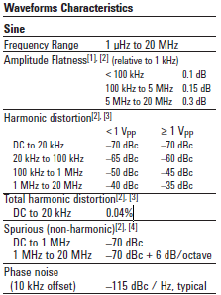
This is the information that we get from the data sheet.
The amplitude flatness for a f < 100 KHz = 0.1dB, to dBV
$$0.1 dBV=20\log\left(V\right)→V=1.011579V$$
To calculate the amplitude uncertainty:
$$Accuracy= ±\left(1\%·1V±1m V_{pp}\right)·1.011579=11.127mV$$
$$Uncertanty =\frac{μ}{k}=\frac{11.127}{\sqrt{3}}=6.424mV$$
PRELAB4-7. Calculate the standard uncertainty of the oscilloscope when measuring the amplitude and rms value of the previous signal. Take into account the oscilloscope noise.
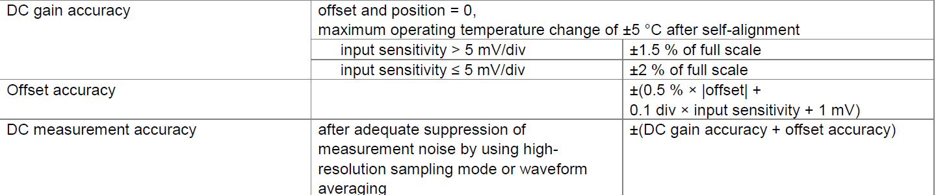
$${Uncertainty}_{amplitude}=\frac{{1V}_{pp}×\frac{1.5}{100}+0.1 div×\frac{5 mV}{div}+1 mV}{\sqrt{3}}=9.526 mV$$
We know that $V_{rms}=\frac{V_{pp}}{2CF};CF=\sqrt{2}$
$${Uncertainty}_{Vrms}=\frac{\frac{{1V}_{pp}}{2\sqrt{2}}×\frac{1.5}{100}+0.1 div×\frac{5 mV}{div}+1 mV}{\sqrt{3}}=3.928 mV$$

